**IoT Security and Privacy**

**Assignment 2 – Raspberry Pi**

**10 points**

### Instructions:

1. Note: Blue text points to a web link. Ctrl + Click to follow link.
2. This is a team assignment. However, each member of the team has to submit the finished assignment. Those who do not submit will get zero for this assignment.
3. Answers to all questions must be put into **ONE** document. That is, every time, each student can only submit one report document, answering all questions of this assignment.
4. Students must put answers following each question in this assignment. The instructor will not grade a report with only answers in it and the student gets zero for such an assignment. An assignment report must include original questions.
5. Students MUST submit the finished assignment in either Microsoft Word or pdf format to Blackboard. The doc must be submitted as ONE standalone file and cannot be tarred or zipped into a container.
6. Refer to [Print screen](http://en.wikipedia.org/wiki/Print_screen) on how to take a screenshot. Pressing the Alt key in combination with PrtSc will capture the currently selected window.

**Questions:**

**Question 1 (8 points)**

In this assignment, students are required to use sensors on raspberry pi. If a group has n members, the group needs to try n different sensors. Ideally, each member works on one sensor and documents according to the requirements below.

Please refer to [1] for use of raspberry pi and [2] for various sensor manuals. Search “manual” in the page for manuals of the sensors.

**Requirements:**

For each sensor,

1. Introduce what the sensor does.
2. Include a photo of raspberry pi with the connected sensor. Explain how the sensor is connected to GPIO pins or the board of raspberry pi. Any accessories such as cameras are considered as sensors.
3. Include the results of your experiments controlling or communicating the sensor.
4. Include the code for controlling or communicating the sensor.

**Question 2 (2 points)**

1. Students will work in a team for the term project. Each team can have at most 4 students. Please identify all team members below.

**Team Members:**

1. Kiran Shettar
2. Omkar Salunke
3. Rohan Girase
4. Tarun Jaykumar Moorjani
5. Please introduce the term project in mind right now.

**Project Idea:**

**References**

1. Chao Gao, [Use of Raspberry Pi](http://www.cs.uml.edu/~xinwenfu/IoT/UseRaspberryPi-ChaoGao.pdf), 2016

1. [SainSmart 37 in 1 Sensor Module Kit for Arduino UNO R3 Mega2560 Mega328 Nano Raspberry Pi](http://www.amazon.com/SainSmart-Arduino-Mega2560-Mega328-Raspberry/dp/B013UL6LFS), 2016.

**Sensors Used:**

1. Camera
2. PIR
3. Humidity
4. LED

**1. LED Sensor:**

Team Member worked: Kiran Shettar

* **Introduce what the sensor does.**

The LED(Light Emitting Diode) sensor converts electrical input signal into light, a closed optical channel (also called dielectrical channel), and a photosensor, which detects incoming light and either generates electric energy directly, or modulates electric current flowing from an external power supply.

* **Include a photo of raspberry pi with the connected sensor. Explain how the sensor is connected to GPIO pins or the board of raspberry pi. Any accessories such as cameras are considered as sensors.**Below is the circuit followed to connect the LED sensor:  
  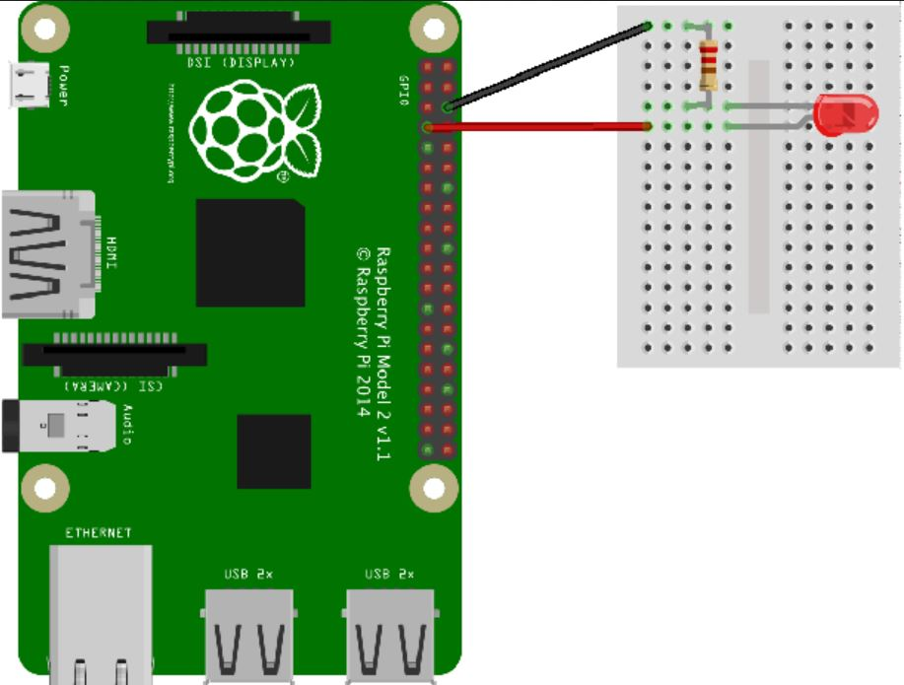  
    
  Process:  
  **>>** GPIO 18 is used as a output pin.  
  **>>** LED CONNECTION: The longer leg (known as the ‘anode’), is always connected to the positive supply of the circuit. The shorter leg (known as the ‘cathode’) is connected to the negative side of the power supply, known as ‘ground’.  
  **>>** Connections were done by connecting to a resistor and also without connecting to a resistor.  
    
  CONNECTION BETWEEN IoT device and the LED sensor: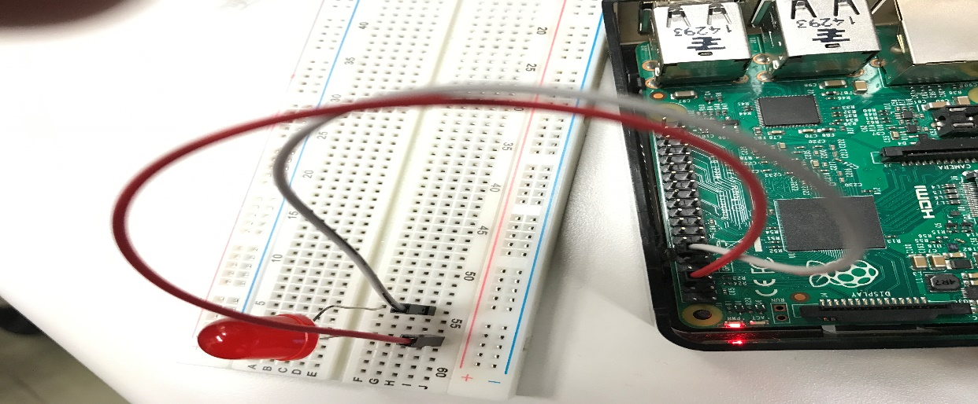
* **Include the results of your experiments controlling or communicating the sensor.**Results of the experiment:The sleep time is 5 seconds in my code which can be modified anytime. Once we run the python code the LED will turn on i.e it’ll be HIGH. After 5 seconds the LED will turn off i.e. it’ll be LOW.   
  If you terminate the code in between then LED will be on.  
  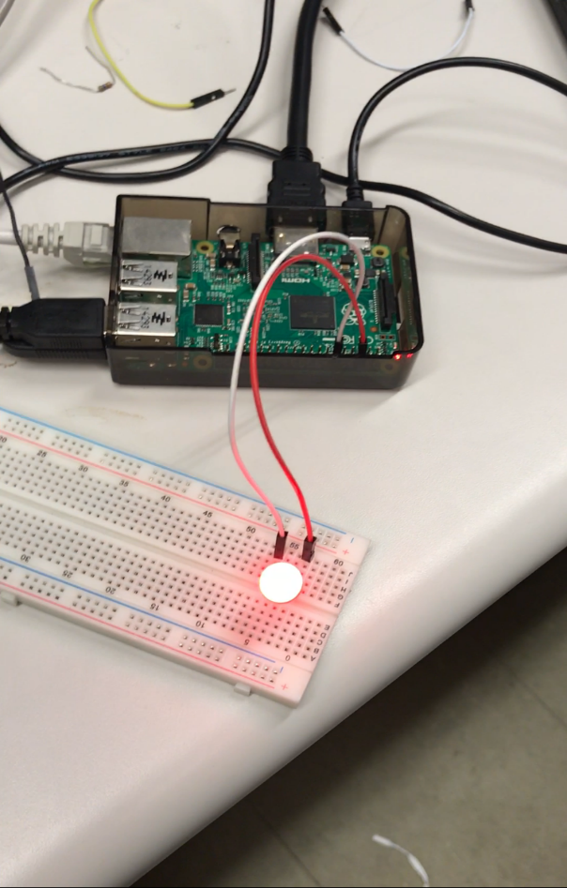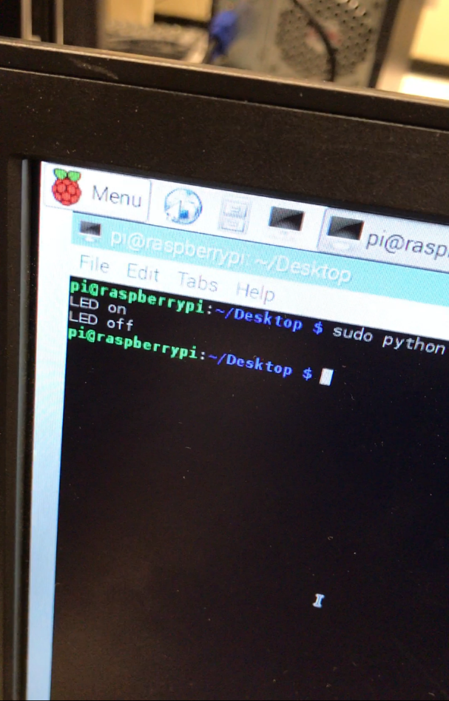

Raspberry Pi connected with the LED sensor and successfully communicating with it.

* **Include the code for controlling or communicating the sensor.**  
  //CODE to communicate with LED sensor

import RPi.GPIO as GPIO  
import time  
GPIO.setwarnings(False)  
GPIO.setmode(GPIO.BCM)  
GPIO.setup(18, GPIO.OUT)  
print “LED on”  
GPIO.output(18, GPIO.HIGH)  
time.sleep(5)  
print “LED off”  
GPIO.output(18,GPIO.LOW)  
GPIO.cleanup()

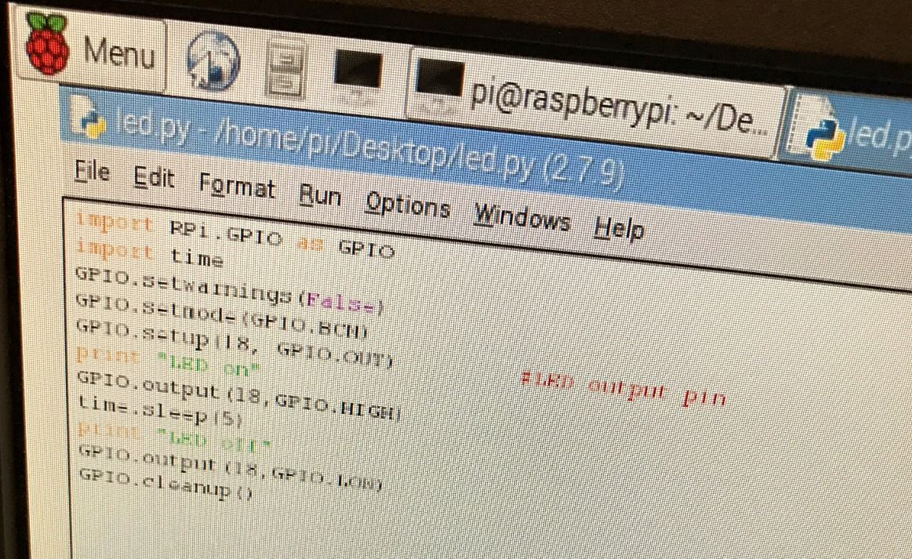

**2. Humidity Sensor:**

Team Member worked: Omkar Salunke

Introduction:

The Digital Temperature and Humidity sensor (DHT) is capable of measuring the Temperature precise to 0.1 F, and relative Humidity upto 0.1 %.

Connecting Sensor:

The sensor is installed in a breadboard. It has 3 connections, named V (high Voltage), G (Ground), and D (Data). The Data input is connected to GPIO-4.

Enabling the Sensor:

The Python Library Adafruit was used for this sensor. Downloaded from github, the Adafruit_python_DHT library allowed the sensor to pass its readings to the terminal.

Code for sensor:

“ h,t = dht.read.retry(dht.DHT22, 4) “

Images:



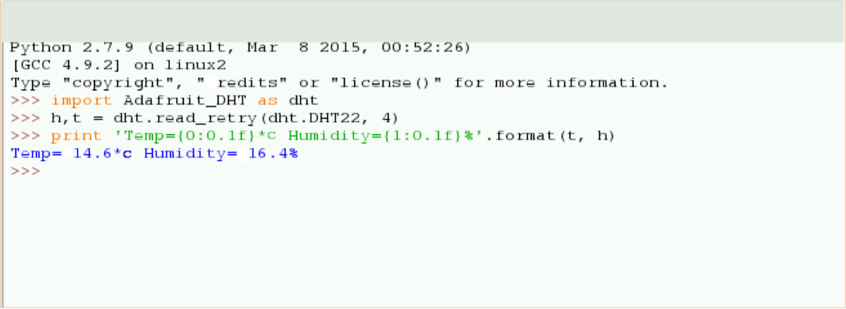

**3. PIR sensor (Passive Infrared Motion Sensor):**

Team Member Worked: Rohan Girase

Introduction: The sensor is regarded as passive because it doesn't send out any signal in order to detect movement. It adjusts itself to the infrared signature of the room it's in and then watches for any changes. Any object moving through the room will disturb the infrared signature, and will cause a change to be noticed by the PIR module. The output is digital. The language used is python3.

Connection:

The sensor is connected to the raspberry pi through the breadboard using an interface.

The three pins of the sensor are connected to their respective ports in the breadboard: Top port (red wire) is connected to the 5v power supply, Middle port (yellow wire) to pin4 of the board and bottom port (black wire) to the ground connection of the board.

Working:

We first create a blank python file with the command: “*nano pir.py*”.

In the file we write the code:

import RPi.GPIO as GPIO

import time

sensor = 4

GPIO.setmode(GPIO.BCM)

GPIO.setup(sensor, GPIO.IN, GPIO.PUD_DOWN)

previous_state = False

current_state = False

while True:

time.sleep(0.1)

previous_state = current_state

current_state = GPIO.input(sensor)

if current_state != previous_state:

new_state = "HIGH" if current_state else "LOW"

print("GPIO pin %s is %s" % (sensor, new_state))

Save the code in the file by clicking “*ctrl+o*” and exit to terminal by typing “*ctrl+x*”.

Now type the following command to run the sensor: “*Sudo python3 pir.py*”

The output is high whenever motion is detected.

Images:





**4. Camera Sensor:**

Team Member worked: Tarun Jaykumar Moorjani

Introduction:

The camera connected to Raspberry Pi is capable of taking 1080p photos and videos and controlled through programs. The language used for coding camera is python3.

Connecting camera:

The flex cable is inserted into the connector slot situated in between the Ethernet and HDMI ports, with the silver connectors facing the HDMI port. The flex cable connector should be opened by pulling the tabs on the top of the connector upwards then towards the Ethernet port. Insert the flex cable into the slot and push the tab down to connect the camera.

Enabling the camera:

After physical connection, open terminal and type “*raspi-config*” and hit enter. Select enable camera option and go to finish and hit enter. When prompted reboot the system.

Code for camera:

“*Raspivid –t 0*”

Images:

